Mac OS X user manual

**Perquisites:**

1. Xcode (acquire it in App store)

**Procedures:**

1. Go to https://github.com/HyDROSLab/EF5, click “Clone or Download” -> “download in zip”
2. Go to the folder you downloaded the source code, open “EF5/EF5.xcodeproj”
3. In the top menu, build this project:

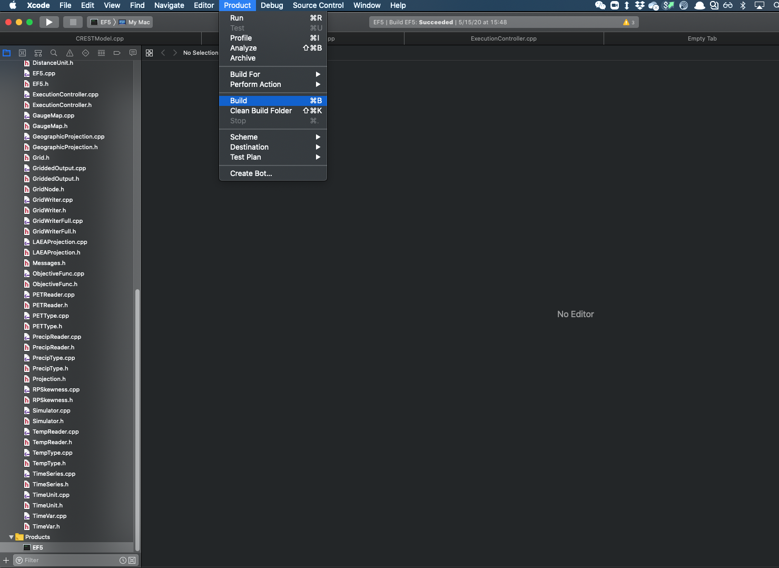

If it builds successfully, you can see the “Products” in the bottom left.

You can move the executable (EF5) to any directory you want.

**Run with control file:**

After compiling the codes, you have to navigate to the folder where the executable exists:

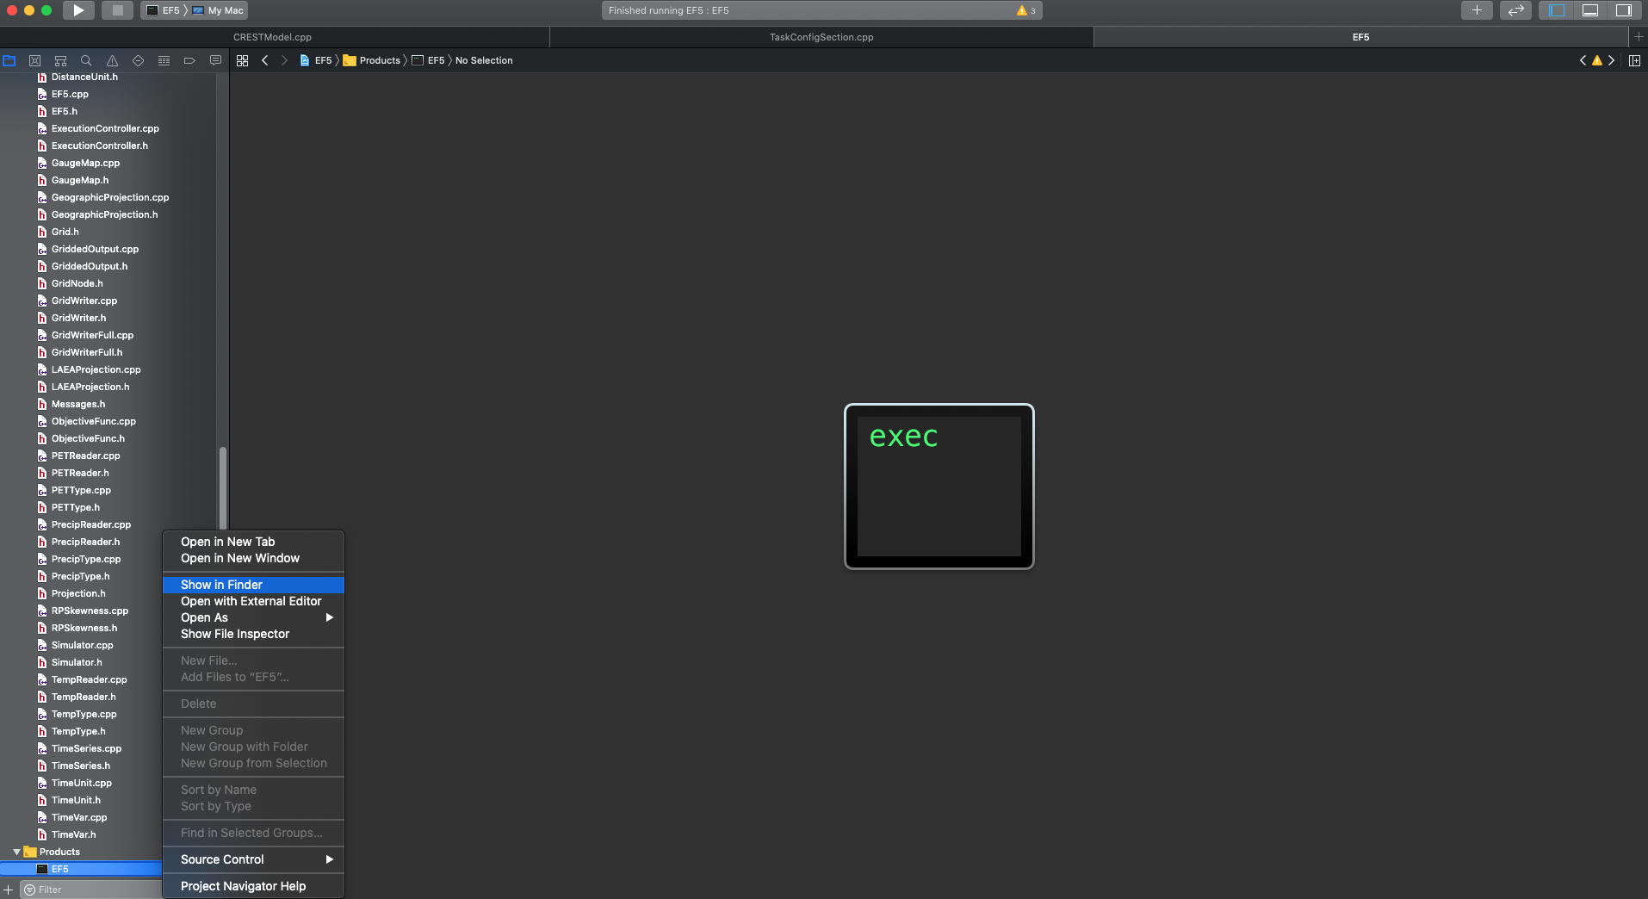

At that directory, open a terminal:

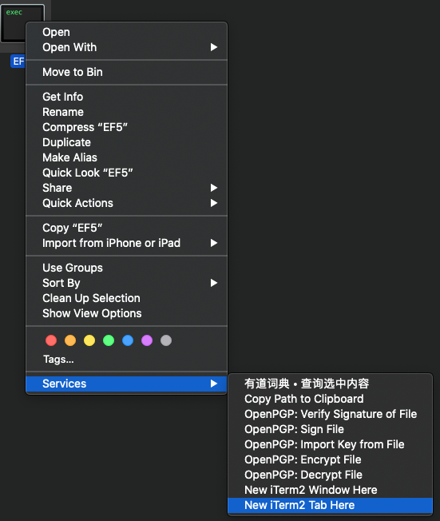

Run the executable file followed by the control file (the full path)

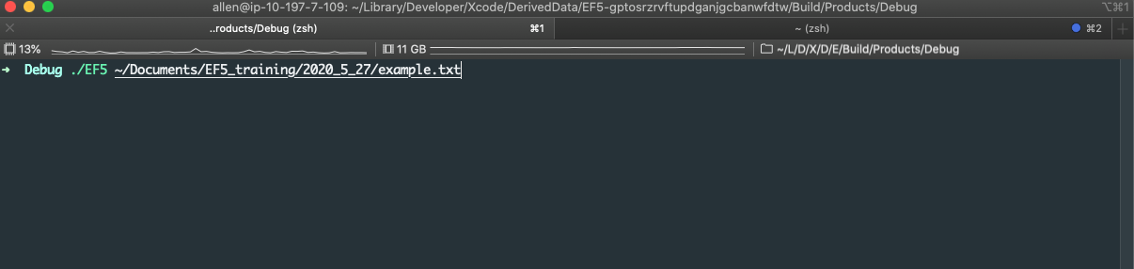

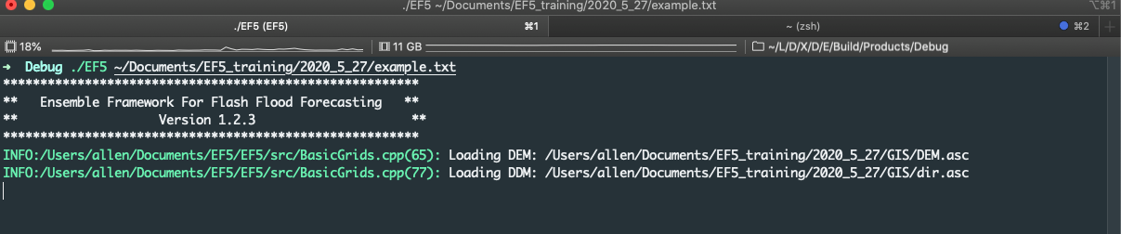

If you have any further questions, feel free to reach me out, and we can provide you with more explanations.

Allen Li: [li1995@ou.edu](mailto:li1995@ou.edu)